
Software Engineering Final Lab Documentation
Spring 2026

Supervised By:
Dr. Amr Ibrahim
A.l. Shaimaa Bahaa Eng. Mariam Ragab

Table of Contents
Team Members 1
Project Idea 1
Problem Statement 1
Problem Solution 1
System Analysis 1
Implementation 2
Testing 2

Team Members
Section CRN | ID | Name
6008 | 200044093 | Malak hanafy mahmoud
6008 | 200058659 | Menna Gamal abdelmotelb
6009 | 200043741 | Martina Nabil Gadeon
6008 | 200047914 | Donia Tarek Musalm
6009 | 200039028 | Jolie Nixon Ezzat

Project Idea
A University Project Tracker is a desktop application built with C# Windows Forms that allows students to register and log in securely, then view their assigned academic projects including details such as title, description, supervisor name, team members, start date, and deadline, while also being able to update the project status (Not Started, In Progress, Completed) and track tasks assigned to each team member, with the system storing all data in a local database and providing a dashboard that displays all active projects, upcoming deadlines, and progress reports, making it easier for students to stay organized and meet their academic requirements throughout the semester.

Problem Statement
University students face difficulties in managing multiple academic projects, tracking deadlines, organizing tasks, and coordinating with team members. Traditional methods such as paper notes or scattered applications are inefficient and can lead to missed deadlines and poor project organization.

Problem Solution
The University Project Tracker provides an organized platform that helps students manage their university projects efficiently. The system allows users to create projects, assign tasks, track project progress, manage deadlines, and collaborate with teammates in one place. It improves productivity, organization, and communication among students while reducing the risk of missing important submissions

System Analysis

1- Use Case Diagram
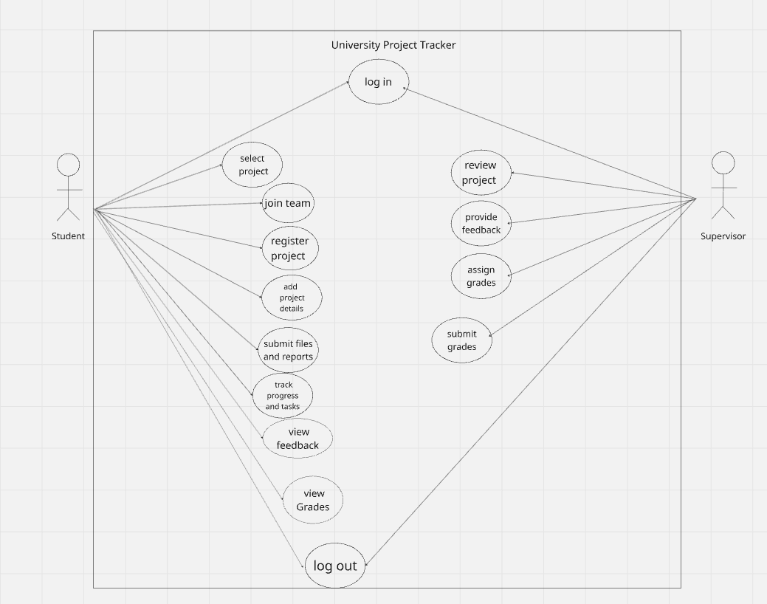
Text description
The Use Case Diagram represents the main functions of the University Project Tracking System and explains the interaction between the two main actors: Student and Supervisor. The student can log into the system, select or register a project, join a team, upload project files and reports, track project progress and tasks, as well as view feedback and grades provided by the supervisor. On the other hand, the supervisor can review projects, monitor students’ progress, provide feedback, and assign grades. The diagram demonstrates how the system helps organize project management, improve communication between students and supervisors, and simplify the process of tracking and evaluating university projects.

2- Class Diagram
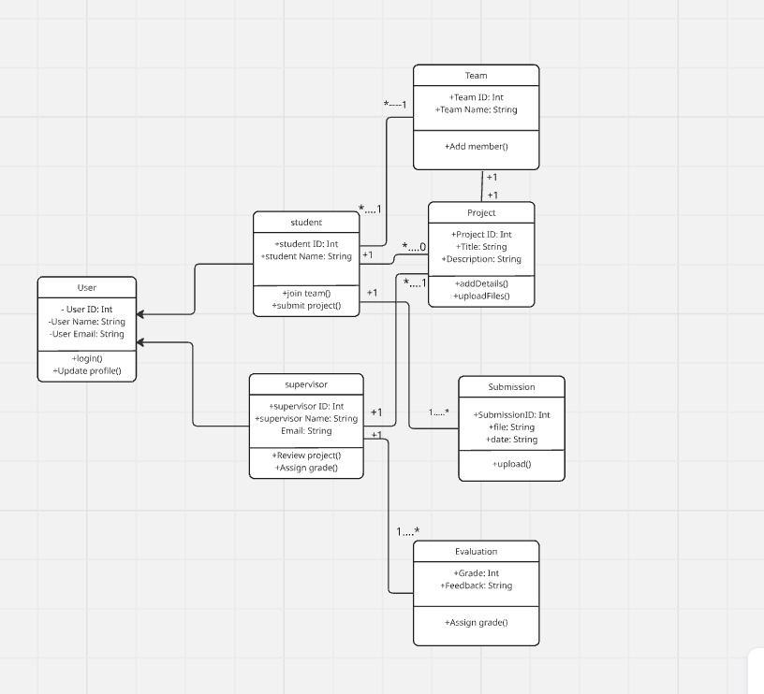
Text description
Structure of the System and Class Relationships
The following diagram presents a comprehensive University Project Tracking System that provides efficient means for managing educational processes. Firstly, we have a base User class with common properties ID, Name, and Email implemented with the help of inheritance principle to describe Student and Supervisor classes.
The flow starts with organizing Students in Team groups working together on a particular Project. The Project itself serves as the key storage of academic works when students may modify relevant data and attach files. The idea behind storing multiple Submissions in the database is preserving records of all the progress made during work on a project with each having an ID, path to the file, and a time of submission.
Finally, in the Evaluation stage, a Supervisor evaluates students' work by reviewing their submission. There is a straightforward relationship established between Supervisor and Evaluation classes, thus allowing the instructor to give grades and comments on students' projects.

3-Sequence Diagram
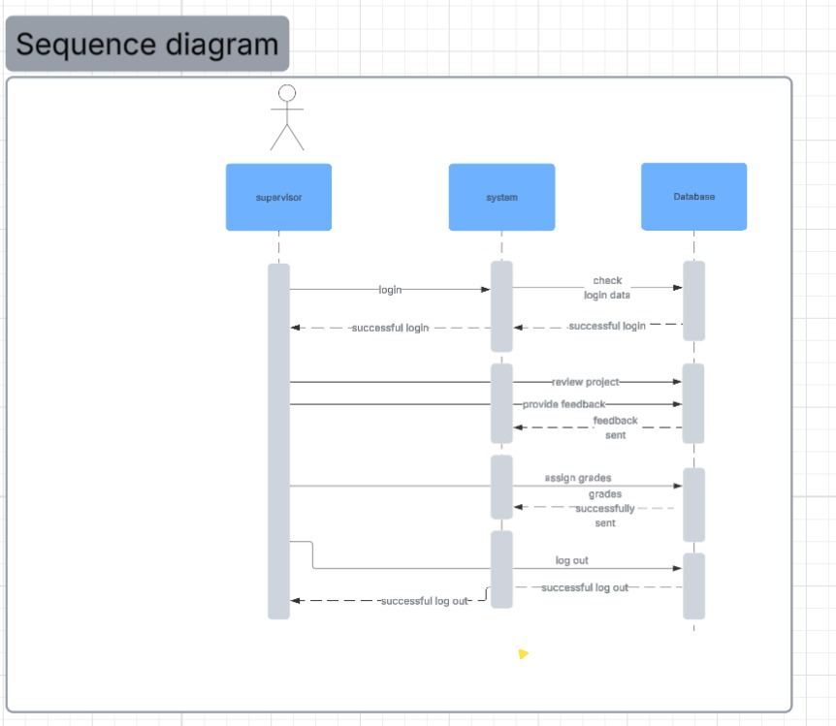
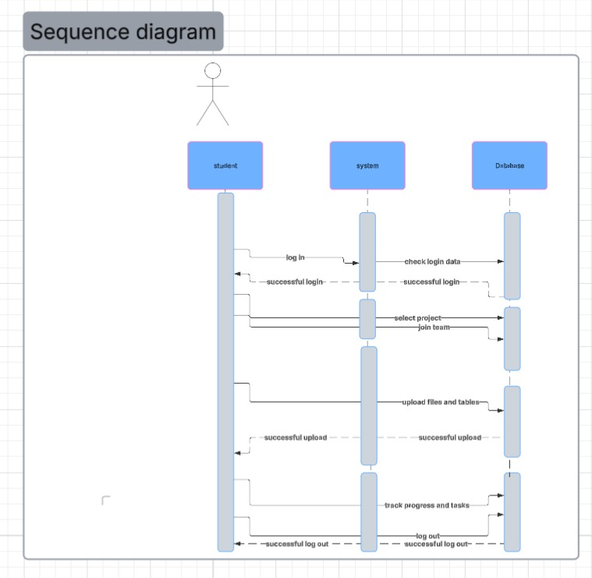
Text description
As seen in the sequence diagrams below, there is a dynamic relationship between the user (Student/Supervisor) and the System Interface and Database of the University Project Tracker. The first activity entails an authenticated login by the users through a secure process that validates the credentials against the database. In the Student scenario, the flow involves activities such as choosing a project to work on, building a group, and the actual submission of the assignment with feedbacks after each activity from the database. However, the Supervisor flow is mainly focused on academic oversight with regard to the activities involved such as the retrieval of assignments from students, giving feedback, and grading the assignments. The flows end with Logout sequences to provide session security and maintain data integrity.

4-Activity Diagram

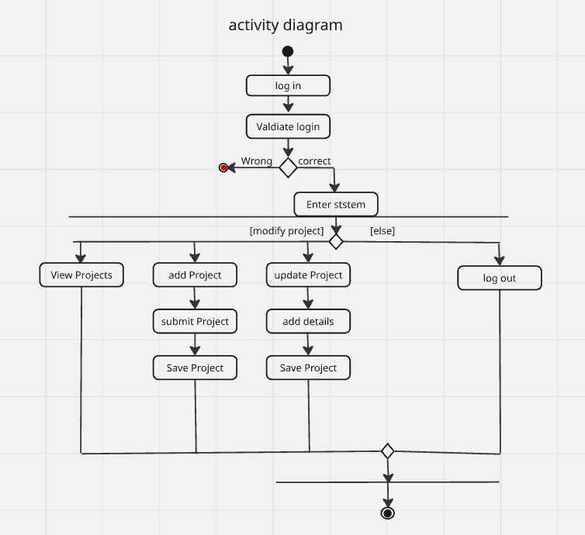

Text description
Activity Diagram depicts the working process of the University Project Tracker beginning with the process of Log-in that involves the validation of user credentials. Depending on the result, the user has two possible ways of entering: he either fails and needs to try again or succeeds and Enters the System. Then, using a structure called Fork, all possible actions that the user can take within the system are represented, which include Viewing Projects, Adding entries, or Updating them. In each case, the steps taken will follow a certain path; if, for example, an action is to add projects, then the next steps will be submission and storage of added projects. All actions end with synchronization by means of a Join bar and finally enter the Final State.

Implementation
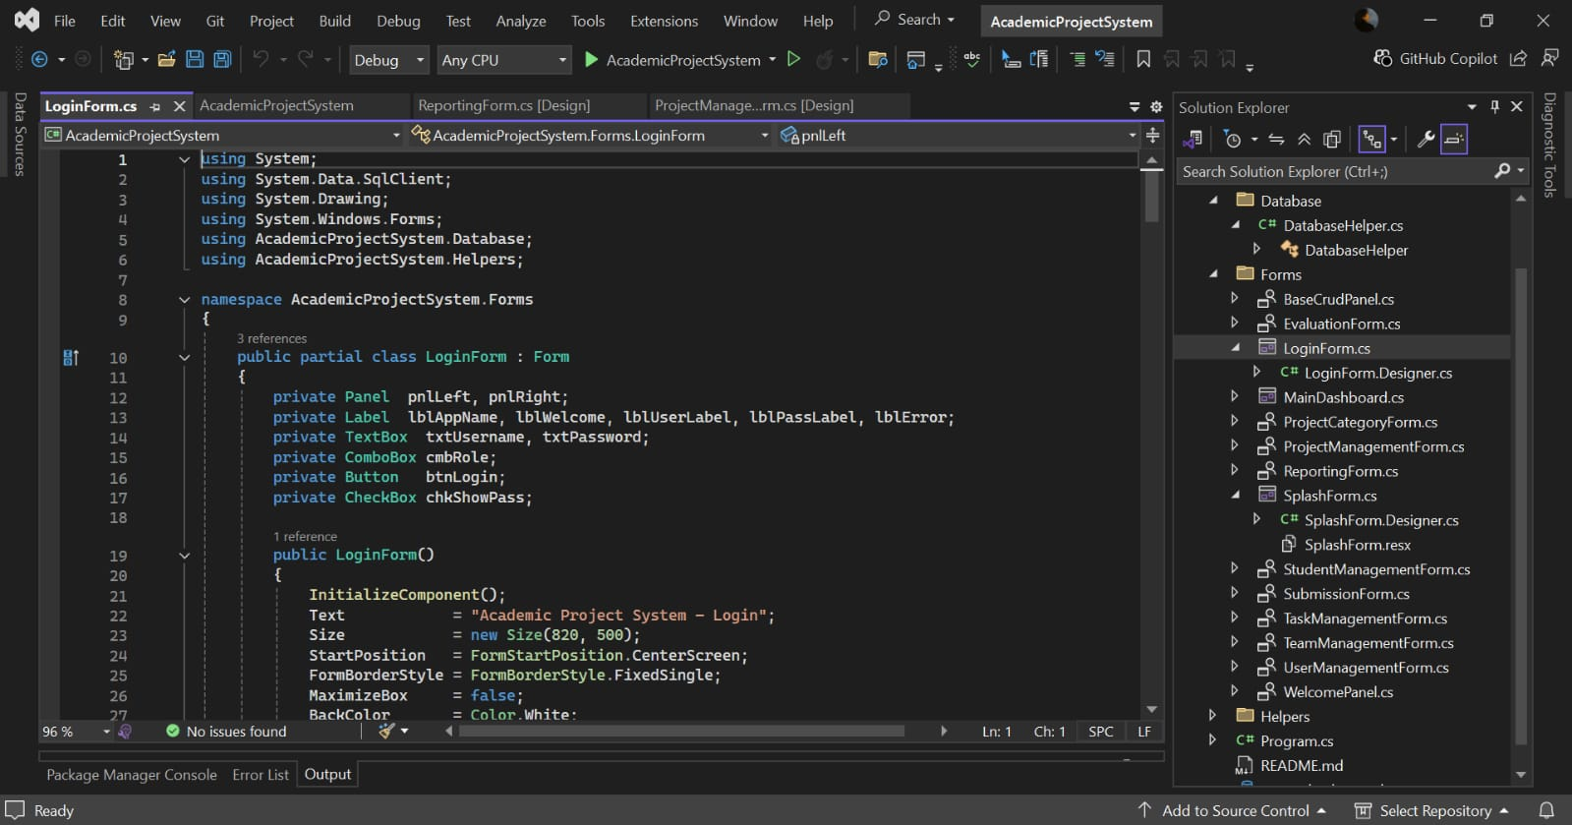

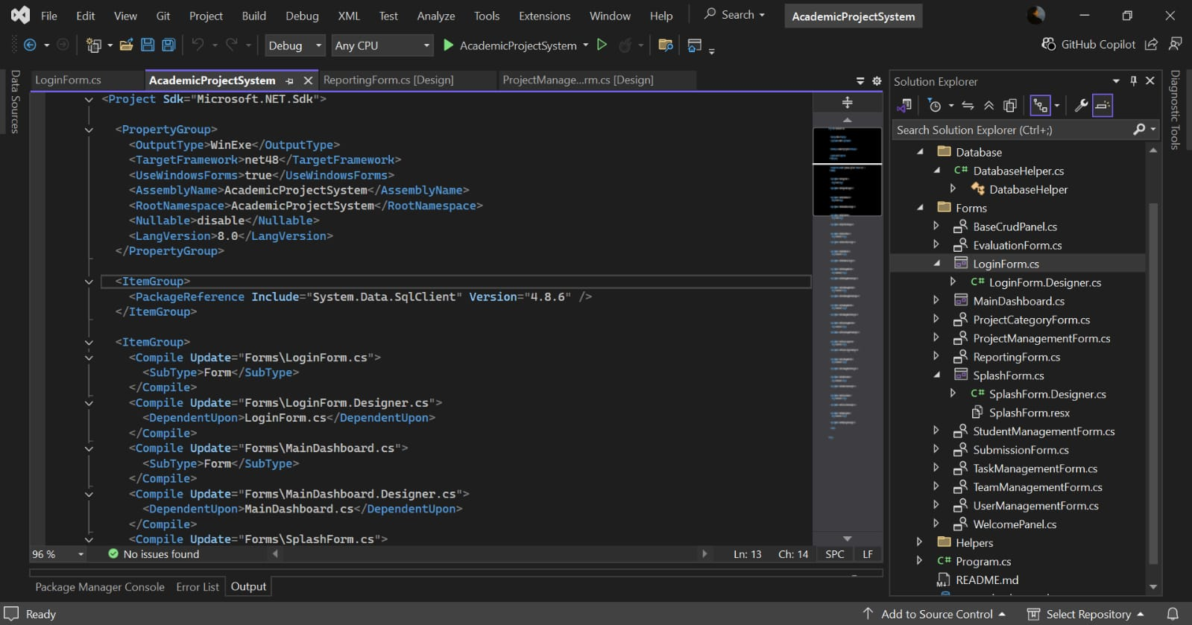



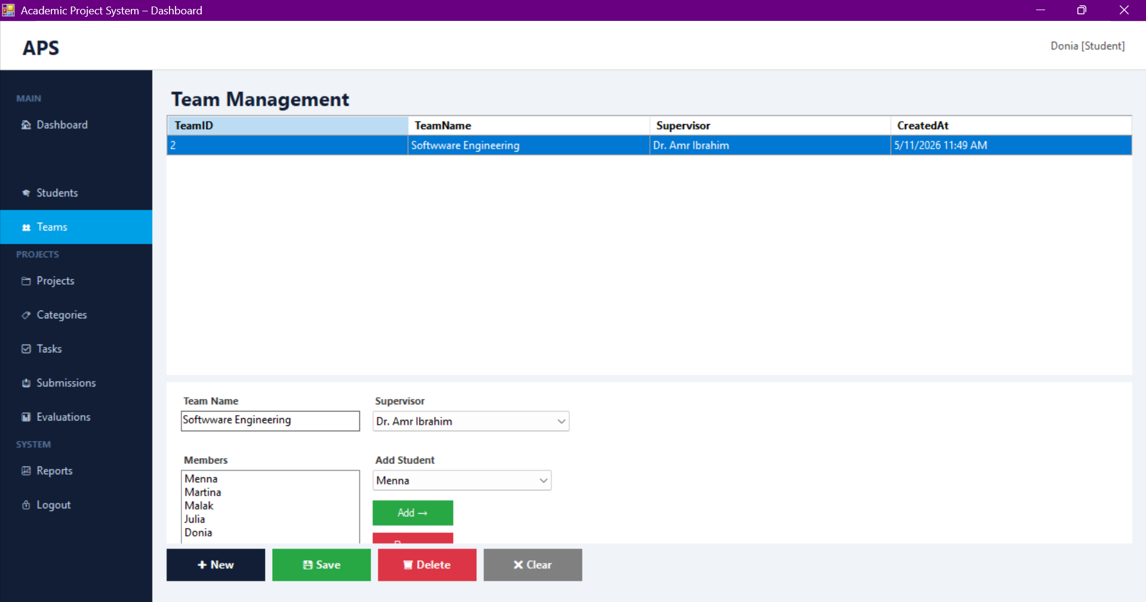
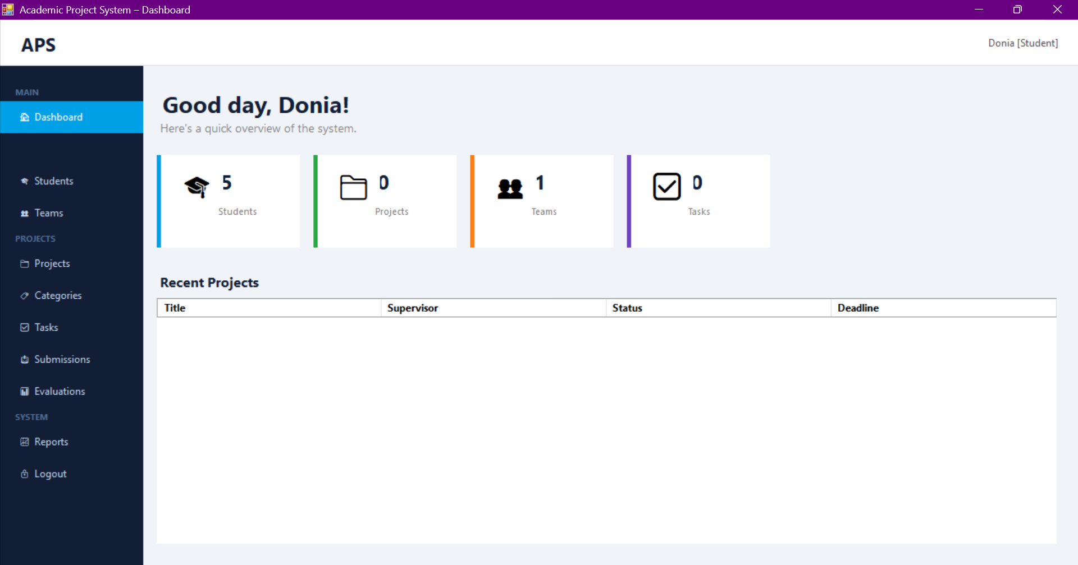
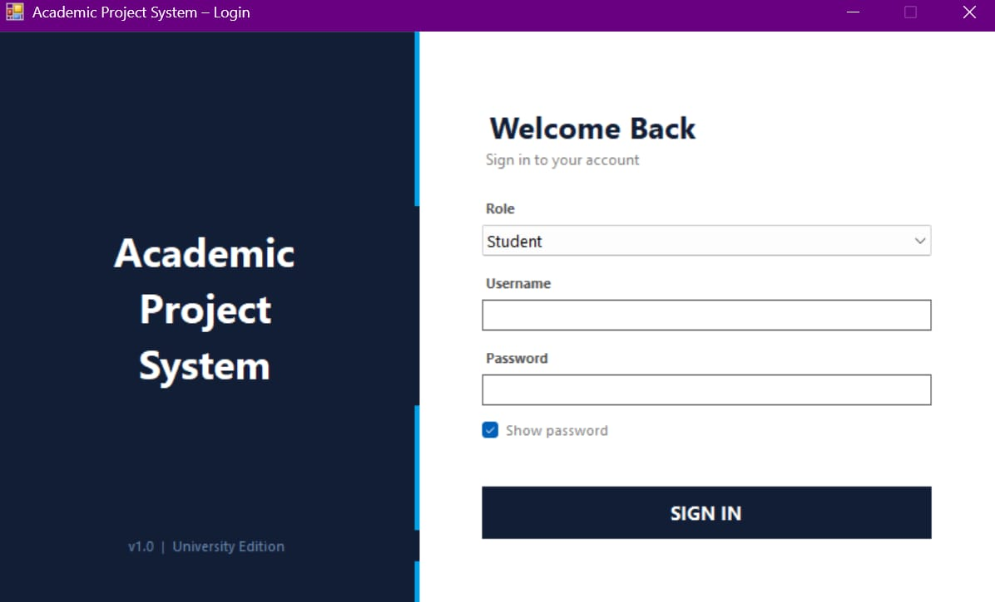

Testing
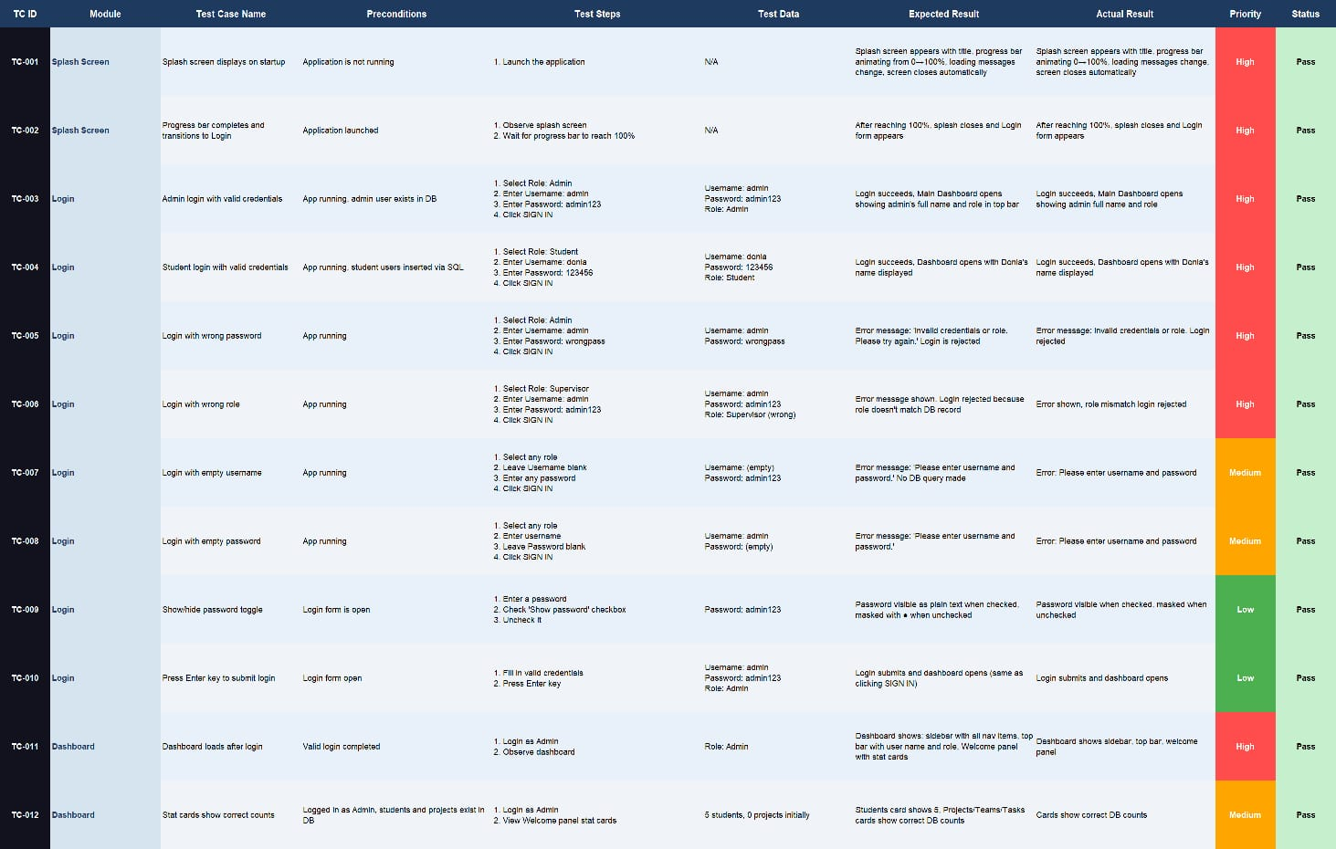

Functional Requirements
1. User Authentication
User can login using username and password.
System validates user credentials.
Different roles can access the system (Admin, Supervisor, Student).
User can logout securely.

2. User Management
-Admin can add new users.
-Admin can update user information.
-Admin can delete users.
-Admin can search for users.
-System stores:
-> Username
-> Full Name
-> Password
-> Phone Number

3. Student Management
-Add student records.
-Update student information.
-Delete student.
-Search for student.
-View assigned projects.

4. Student Management
-Add student records.
-Update student information.
-Delete student.
-Search for student.
-View assigned projects.

5. Database Management
-Store all records in SQL Server database.
-Secure data handling.
-Backup and restore database.

Non-Functional Requirements

Performance —load and display project data within 3 seconds.
- Security —encrypts user passwords and restrict access based on user roles (student/admin).
- Usability —have a simple and easy-to-use interface that requires no technical knowledge to operate.
- Reliability — available at all times without crashes or unexpected shutdowns.
- Maintainability —well-organized and documented to allow future modifications easily.
- Scalability —able to handle an increasing number of users and projects without affecting performance.
- Compatibility — The system run on any Windows operating system.
- Data Integrity —ensure that all stored data is accurate and protected from corruption or unauthorized modification.

